IFOMPT conference 2024



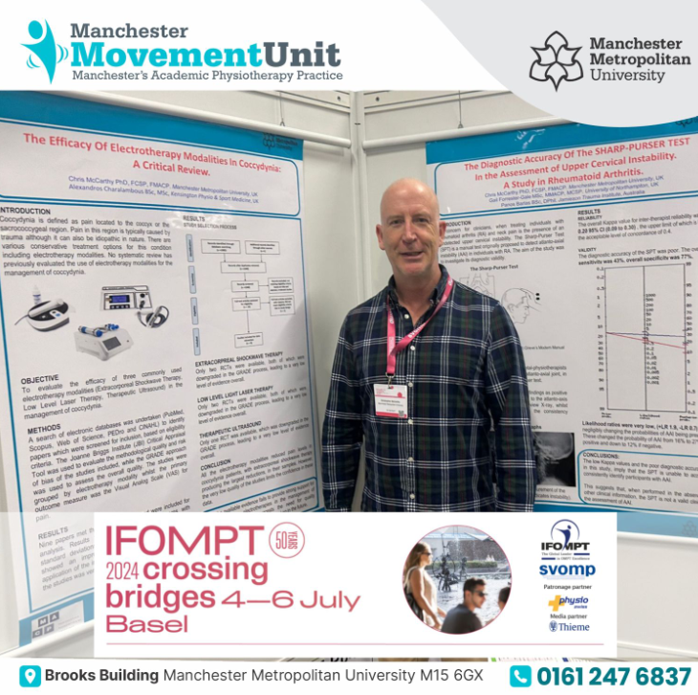

Dear MACP Executive,

I was delighted to be awarded an IFOMPT award and attend this fantastic conference. My attendance allowed me to develop my own personal knowledge and thusly pass this on to the MACP students and colleagues I work with here at Manchester Metropolitan University.

The conference attendance allowed me to network and develop collaborations with a number of international colleagues and promote the MACP widely. You can see that the posters I presented (unfortunately, I am blocking a view on one of the posters in the attached picture) we acknowledged the MACP on the posters and abstracts.

The new three-day format of the IFOMPT conference allowed a highly intensive burst of learning and professional networking and the MACP presence was impressive. I am very grateful to have received the funding and will acknowledge the MACP in the subsequent publications.

Many thanks

Dr Chris McCarthy FMACP, FCSP